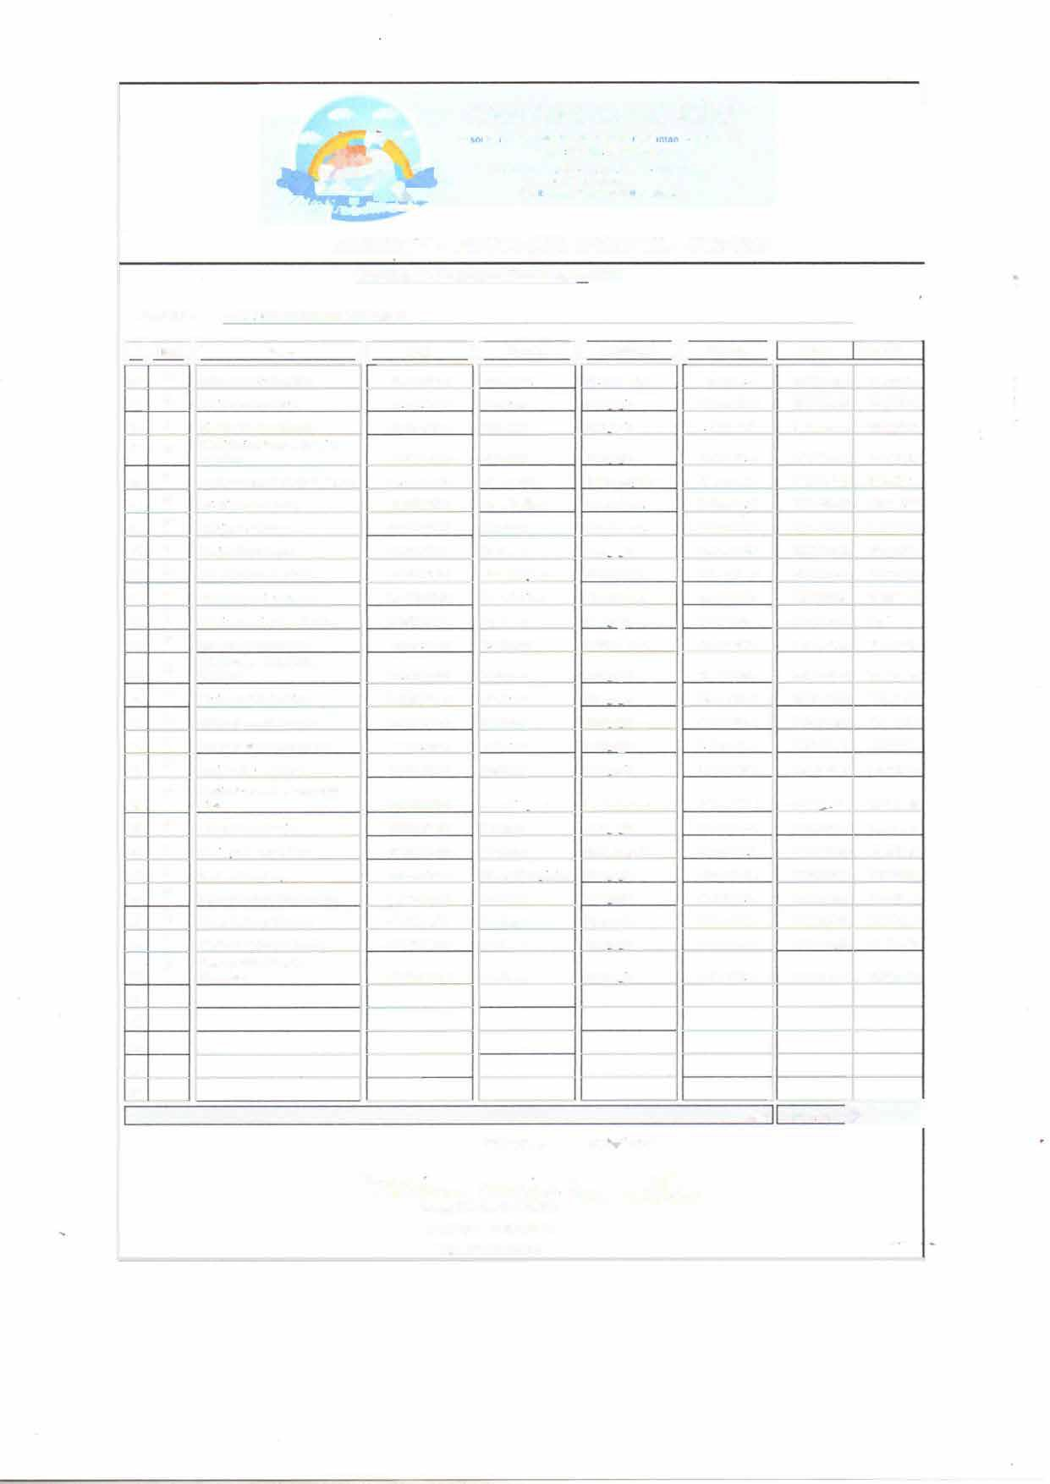
�·�
,
-
CANTINHO DO CEU
1
A· :1,1c lo C.omuntlàna e Cuth11di M, ,,. S; • Umdadl• li
CNPJ 01.273 298/0004•19
Hua Ro•1aldo 201 Jd S1a Mena G11a,ulh0s
Cff' 07096-080
Emo oc:c.rn:.1nosontono2 gmoilc.om
,�
,,,
� .......
-
•
,.,.)....,...
ANEXOIV-
EDUCAÇÃOINFANTIL - CRECHE
Quadro de Recursos Humanos - 2025
ACC Maria Santana Unidade li
E11tidade:
1
li R.G. li
li
li
1 n•1 Unid. 11
Nomt
Função
nabililaçio
Horário
SaUrio
Conta N•
En,ino Médio
16922727-SO
Au.,. Adm
19 962 194-9
Profc�sor
Prof(.'SSOT
Pcda2ou1a
55.131.815-6
18529.472-8
Professor
PcdaJ?oJ?ia
As.sist. Adm.
Ensino Sur>C'rior
50 804.1%-X
41.857.502-2
Atn.Cozmha
En-sino Fund
Pós Graduado
22.564.098-3
Dirctor(a)
-16.184.318-3
Profr'l;.SOf
35.44R.747-4
Aux. Lirnneza
En.sino PWld.
Ensino Fund.
29.498.883-X
Au't. Cozinha
52.898.162-26
Professor
Pcda2ooia
Coziolw:ira
18.010 301-5
52 559.226-3
Professor
14.065.249-30
Profcl!.!'k>T
27.241.196-6
Pruíc>SOr
Prufc�sor
5-1. I 10 219-5
2H67.3ó6-7
Professor
AlL,. Ltmoeza
24.950.565-4
48.008.612-6
Professor
42.514.8-10-3
Profcs54.,r
24.834.682-9
Coord. Peda,01Z1co
:!l.57:!.072-6
Professur
48.216.638-1
Professor
42.264.236-8
Profc�or
Proíes..-.or
27.HJ..141-4
RS 66.924,00-
Tolal
05109/2025
Guarulhos
�"- �
��\
��<:)-..
Tania l\laria de Castro
Prcsidcnlc da Entidade
RG.: 17.564.398-2
Pedaco1na
Pcda2olria
7:00 .., J6•4g
RS2.200.00
735091065
7:00"" 16:48
RS2.804.00
721754242
7:42 a.s 17:30
RS2.084.00
720539873

7:00 as 16·4�

RS2.80-I.OO

73741372'1
7:00 as 16:48
RS3.84ó.OO
717062091
7:00as 16:48
RS1543.00
733440"08
7:00as 16:48
RS4.ó00.00
7349898R 1
7:420$ 17:30
RS 2.8Q.J.OO
734-128941
7:00 a., 16:4�
7:00 as 16:49
7:00 as 16:48
7:00 as 16:48
RS 1.543,00
734990526
RS1.543,00
7.12821614
RS 2.804,00
732800044
RS1.89-1.00
7)4314189

7:00 as ló:48
7:00 as 16:48

RS 2.80-l,OO

737012183
RS 2.804.00
RS 2.804.00
733951734
735087552
7:00 a. 16:48
7·00 a,. 16:48
7:00as 16:4�

7:00 as 16:48
7:00 as 16:48
7:42 as 17:30
7:42 as 17:30
7:42 as 17·30
RSl.80-1.00 RS2.X0-1.<XI
RS 1.543.00
7351-11911
71XM3273

734728202
RS2.80-I.OO RS 2.80-I.OO
793728958
732823906
RS4.068.00
734294028
RS 2.804,00
114453858
7:42 as 17:30
RS 2.8Q.J.OO
716137565
7:42 "'' 17:30
RS2.80-I.OO

RS 2.R04.00
992150474

734330792

7:42 a.< 17·J0

Ensino MéJio

Peda2ogia
Pl-c.lallollia PcdaJtu1tia
Peda,02ia Pcdaooora

Ensino Méd.Jo
Peda202ia
Ensino Su�rior
Pcd0202ia Peda.02ia
Pedagogia
Pcda�olrl.ia

Pcdagoma

OI li
An1one1Ji Olheira Major
02 li
OJ li

Admma Gomes Ah t..�
Bianca da Costa Santana
04 li

os li
(h1c1dc I rJncisco de Oliveir.a
Lourenço
Carlos Eduardo Dei 8u'ISO Albanu
06 li
Cmle, Alvcs da Silva
07 li
Crisllane Dei Busso
08 li
D•nrcla Ruyz Estruc
09 n

Eli�odra Lima dos Santos:
10 u
Fernanda da S1ha Santos
li u
Gabnela PcrelfB Rosa da Silva
12 u
Ivone Bueno Gonçah·es
Jadely \'anessa Lima Pinlu Sobrinho
Jé)s1ca de Oliveira Silva
li
13
- li
- li
Kãthia Apa1u:ida Fcm:irJ
16 li
l.Jum Gah ão Lemos Sa11ltin:t Lem de Oh, eira R06Sim
17 li
li
18

Lindrnaha Maria da Conceição Srha
Luana Gomes Pereira
19 li
20 li
Manlevde Soares Sabino
21 n
Marlene Braz Root!é
- li
- li

Rosana de Souza Menez Biano Talrta Machado Martinc-s
24 li
Vidane Perclm de t\hncida
li
2�
26
Vi\>ianc Tchani d.1 Silva Gonçahc.'-

27
28
29

30

